**DAILY ASSESSMENT FORMAT**

|  |  |  |  |
| --- | --- | --- | --- |
| **Date:** | **21.05.2020** | **Name:** | **K.Naga hemanth** |
| **Course:** | **TCS ION CAREER EDGE** | **USN:** | **4AL18EC027** |
| **Topic:** | **1.The power of Telephone Etiquette.**  **2.Basics of Accounting.**  **3.Techinical competency.** | **Semester & Section:** | **4TH SEM**  **& A SEC** |
| **Github Repository:** | **nagahemanth** |  |  |

|  |
| --- |
| **FORENOON SESSION DETAILS** |
| **Image of session** |
| **Report – Report can be typed or hand written for up to two pages.**  **The power of Telephone Etiquette:**   * This module explain about making the calls in a pofessional manner. * It also explain about the phrases to be used while having the conversation. * It also helped in knowing how to deal with connection errors,how to answer a call,responding to the caller ,etc., * Tips to take telephones messeges,Do's and Don'ts of placing the calls on hold. * Features of voicemails,guildelines for telephone etiquette, and basic telephone courtisies,etc., * Answering the phone within 2-3rings and ask for permission before putting the call on hold   **Basics of Accounting:**   * This module explains about the basics of Accounting. * Accounting is a langugage of Business and it is a sysytem which collects and processes the system * It also explains about the double entry system approach. * Also explain about the joutnals and ledgers, Accounting assumptions,etc., * It helps to know about the accounting standards IASC(1973), IASB(2003).   **Techinical Competency:**   * This module explain about the Techinical competency. * Interviewees seem to have knowledge on various technologies. * Student Management system has normalized tabled designed for transactions. * Management wants stats for spending for a college for a quarter. * Warehouse is new database, primarily for reporting and analysis of data.  |  |  |  |  | | --- | --- | --- | --- | | **DATE:** | **21.05.2020** | **NAME:** | **K.Naga hemanth** | | **COURSE:** | **PYTHON** | **USN:** | **4AL18EC027** | | **TOPIC:** | **Project exercise with 1.python and mySQL:**  **Interactive English dictionary.**  **2.Data analysis with pandas** | **SEMESTER & SECTION:** | **4TH SEM & A SEC** | |

**Afternoon session details**

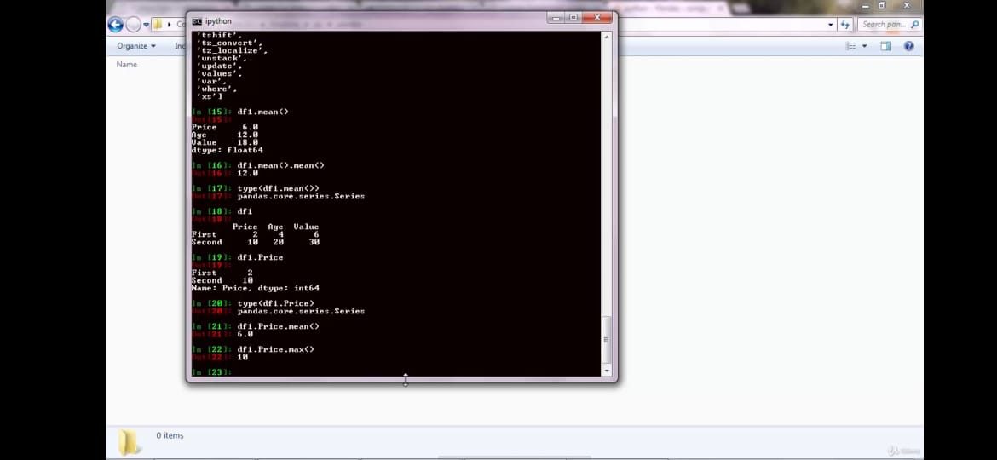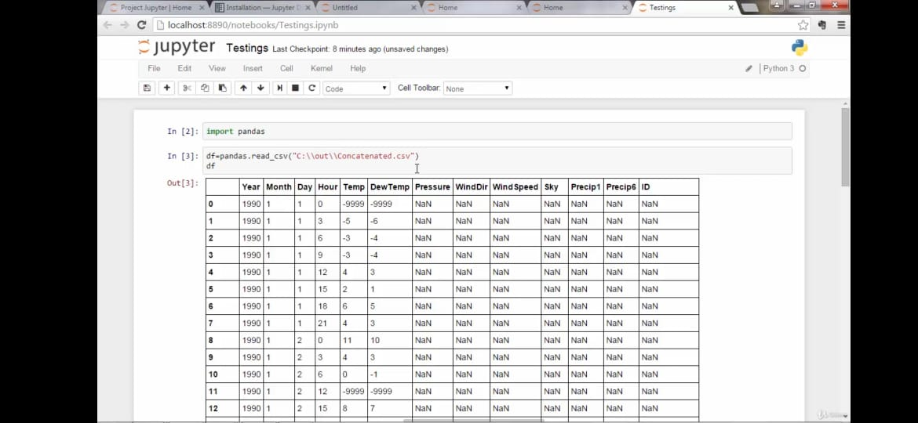

* What is pandes and introduction to pades.
* How to use pandes , as it is very important library.
* Indexing and Slicing.

* Deleting Columns and Rows.
* Using an enhanced python interactive shell called Ipython. And it prints the data in a well structured format.
* Jupiter working with the python and creating a jupiter note book.